**SQL QUERIES OUTPUTS**

**Sample Dataset**

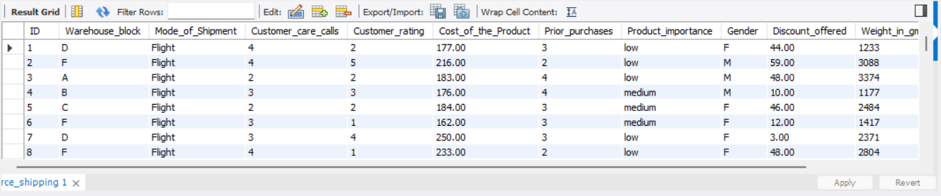

1. **Total number of orders**

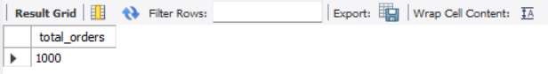

1. **Orders delivered on time vs. delayed**

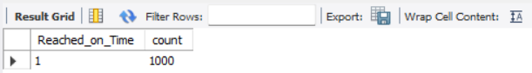

1. **Average customer rating per shipment mode**

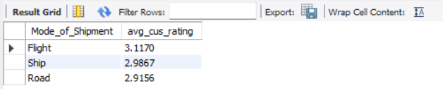

1. **Orders arranged based on their cost with high product importance and delayed delivery**

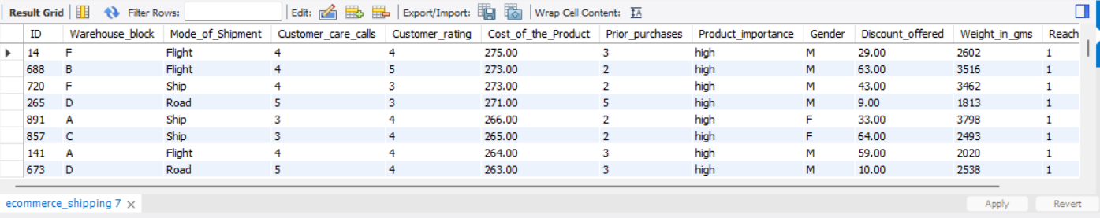

1. **Average cost of products per warehouse**

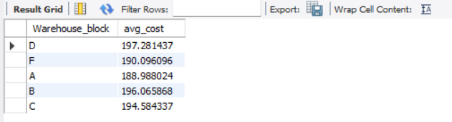

1. **Total discounts given by shipment mode**

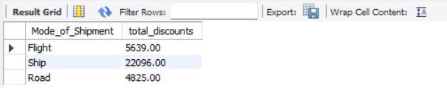

1. **Average weight of delayed shipments**

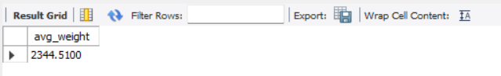

1. **INNER JOIN with shipment_speed**

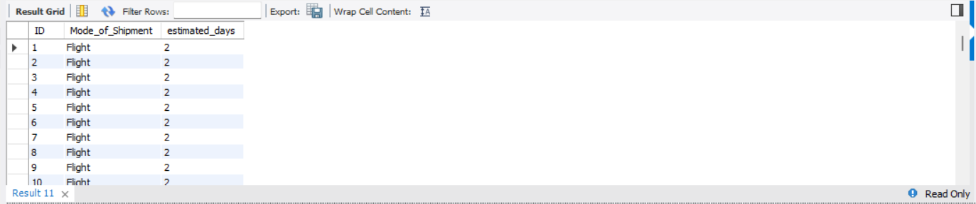

1. **LEFT JOIN**

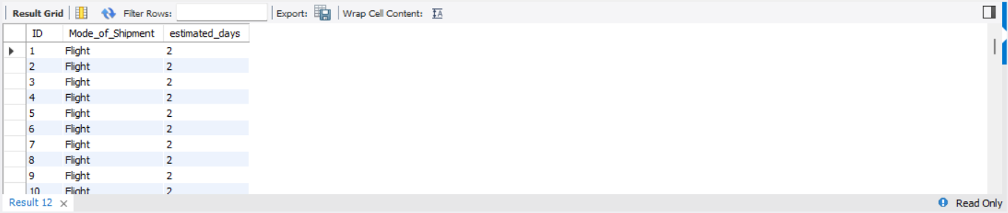

1. **RIGHT JOIN**

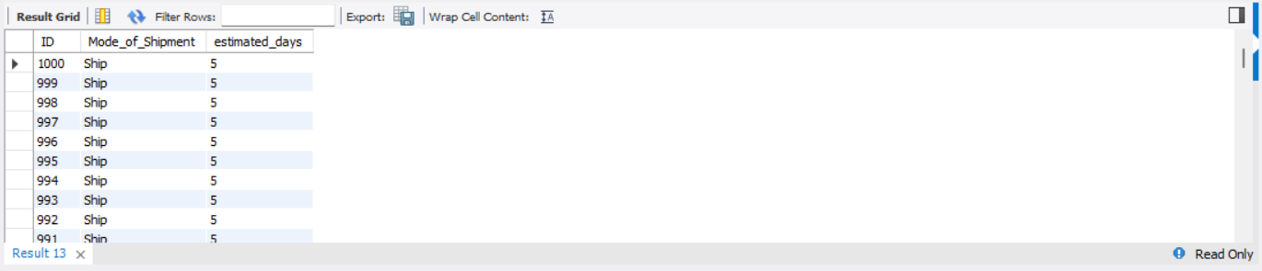

1. **Customers who received a product costlier than the average**

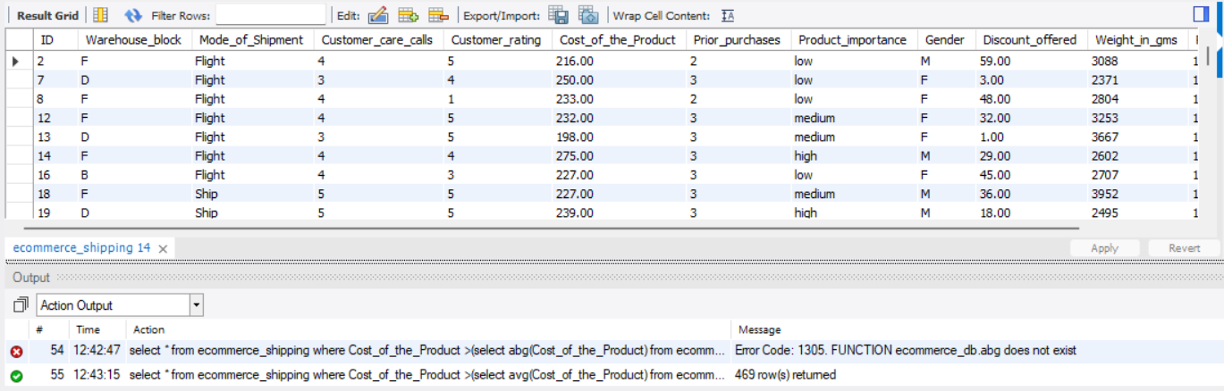

1. **View to track average rating by gender and shipment mode**

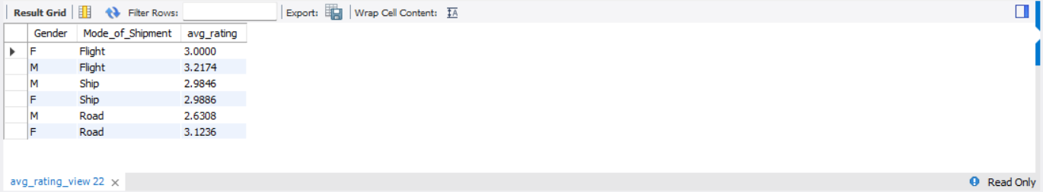

1. **View of delayed high-importance orders**

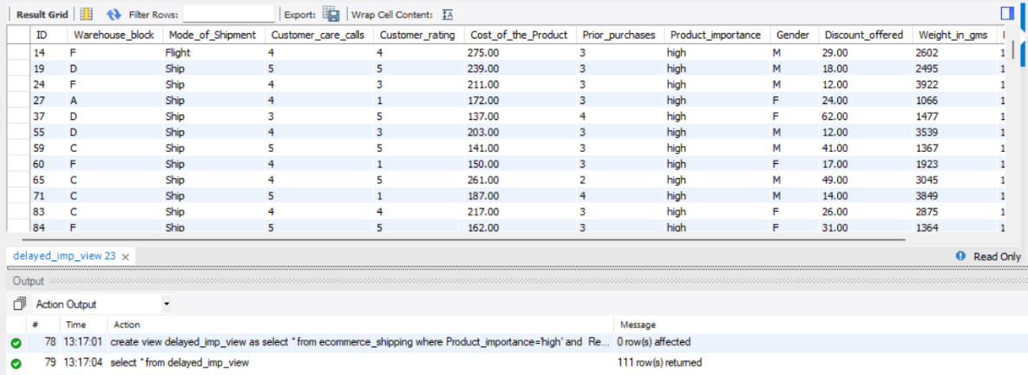

1. **Index on delivery status for faster filtering**



1. **Index on mode_of_shipment for group-by queries**

